***Calculator−free Solutions***

1. (a) (i) or ✓

(ii) ✓✓

(b) (i) ✓

(ii) ‘9’ from first set only: ✓

‘9’ from second set only: ✓

no ‘9’ chosen: ✓

total ✓ [8]

2. (a) (i) ✓

(ii) ✓✓

(b) ✓✓

(c)

✓✓ [7]

3. (a) ✓

(b) ✓✓

(c) ✓✓ [5]

4. (a) (i) ✓✓

A and B are inverses of each other. ✓

(ii) ✓

✓✓

4. (b) (i) T1 performs a rotation of 180°

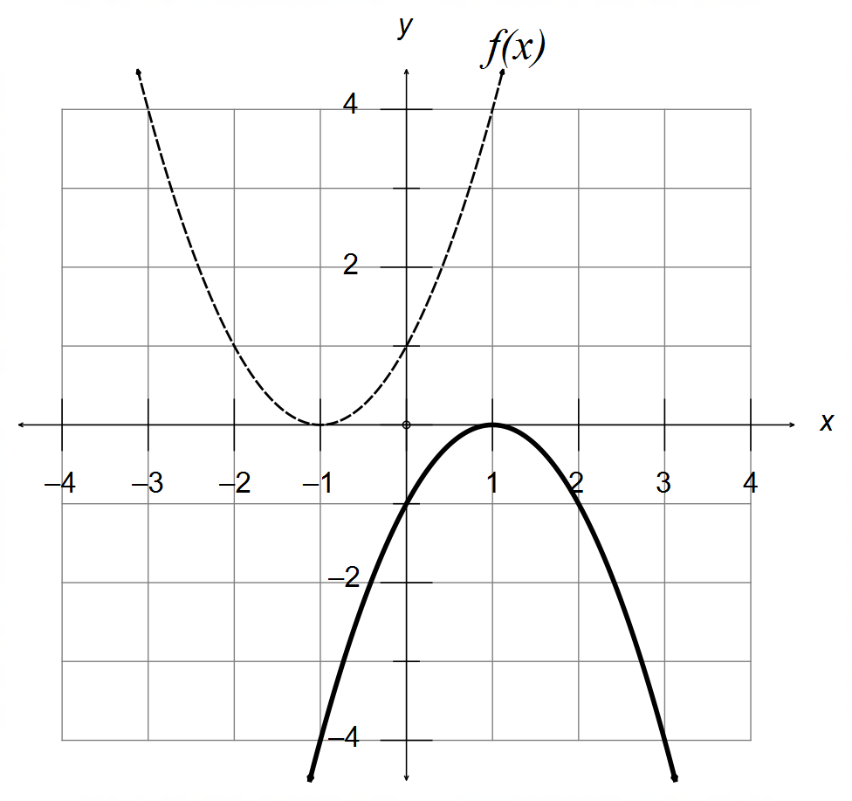

✓✓

(ii) Reflection of the line ✓

T2 ✓

(iii) New Area ✓✓ [12]

5. (a) (i)

✓✓✓

(ii) ✓✓

(b)

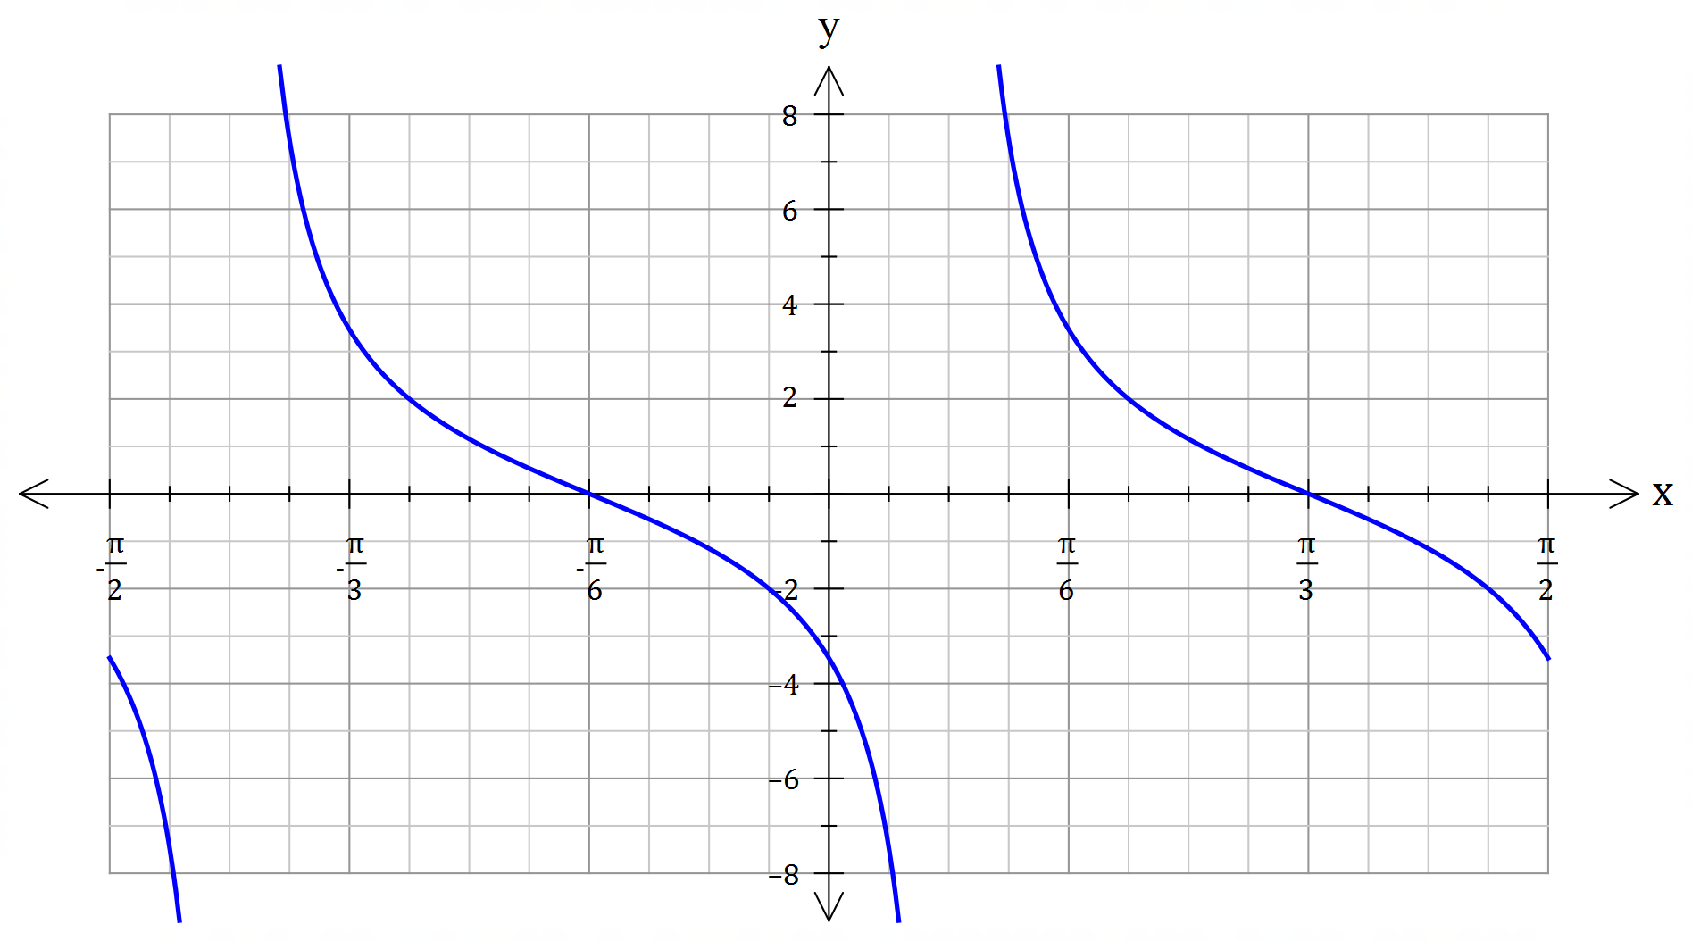

✓ Scale factor

( $y=2$ at )

✓ Period of

✓ Vertical Asymptote

at

[8]

6. (a) (i) ✓

(ii) “If $ab$ is irrational, then both $a$ and $b$ must be irrational” ✓

(b) A ⇒ B: If the triangle has two equal sides, then it is isosceles,

and therefore it has two congruent sides.

$∴$ A ⇒ B is valid and True. ✓

B ⇒ A: If the triangle has two congruent sides, then it is isosceles,

and therefore it has two equal sides.

$∴$ B ⇒ A is valid and True. ✓

A ⇔ B

(c) ✓✓ [6]

7. Assume $n$ is even and that $n^{3}$ is odd. ✓

Let $m∈N:n=2m$ is even. ✓

✓

Since $n^{3}$ cannot be both even and odd simultaneously, then this

is a contradiction. And therefore $n$ must be odd. ✓ [4]